26th Annual

Basketball Tournament
February 12 – 15, 2021

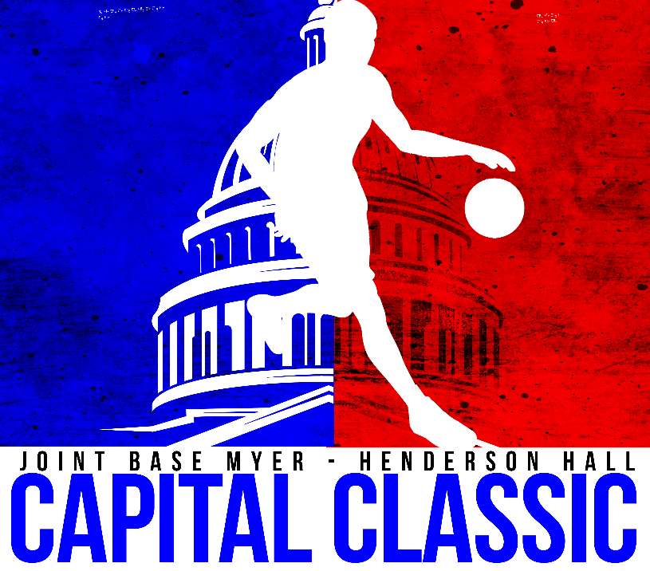
Sponsoring this tournament
is a
SLAM DUNK!

THIS IS YOUR OPPORTUNITY
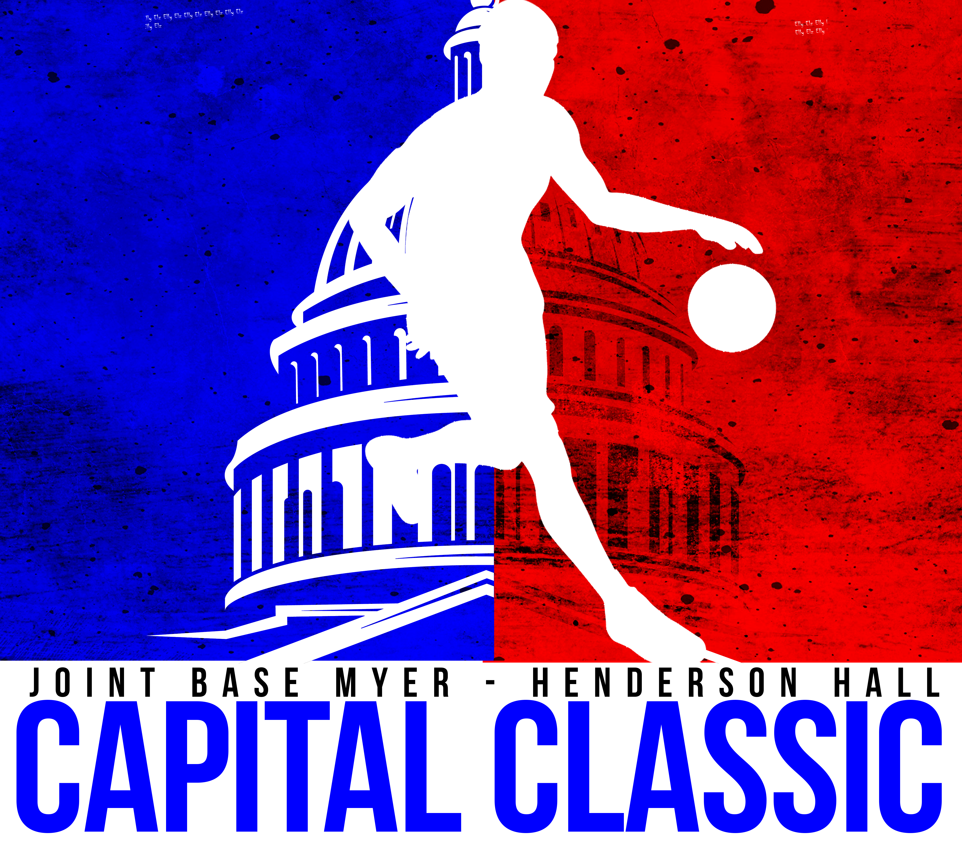

to support active duty military service members
and their families from all branches of the Armed Forces.

Joint Base Myer-Henderson Hall (JBM-HH) has been the proud host of the largest annual joint services basketball tournament in the last 26 years. Through the tireless efforts of several Sports Directors in the Washington Area Military Athletic Conference (WAMAC), the tournament now hosts men’s and women’s teams from all over the country and sometimes from around the world, even Navy ships.

Our goal at JBM-HH is to build a successful, large tournament with the participation of top-ranked men’s and women’s teams from all military services furthering athletic excellence through partnership. The success of the tournament has resulted in many teams returning again and again to compete for bragging rights. The success of the tournament also continues to spark the interest of professional team scouts and national corporate sponsors.

- Your message will reach active duty service members and their families on different installations throughout the DC Metro Region (approximately 150,000 military personnel within 50 miles of our base), as well as those teams from other parts of the country

- You will have the ability interact with tournament participants and spectators throughout the event (a total over 5000 during the 2020 event)

- Get up close and personal with the players and coaches

This four day basketball tournament is one of the largest tournaments of its kind in the Department of Defense.

When: President’s Day Weekend 2021
Friday, February 12 through Monday, February 15

Where: Fort Myer Fitness Center (host location)
Fort McNair Fitness Center
Smith Gym Henderson Hall
Joint Base Anacostia-Bolling Fitness Center
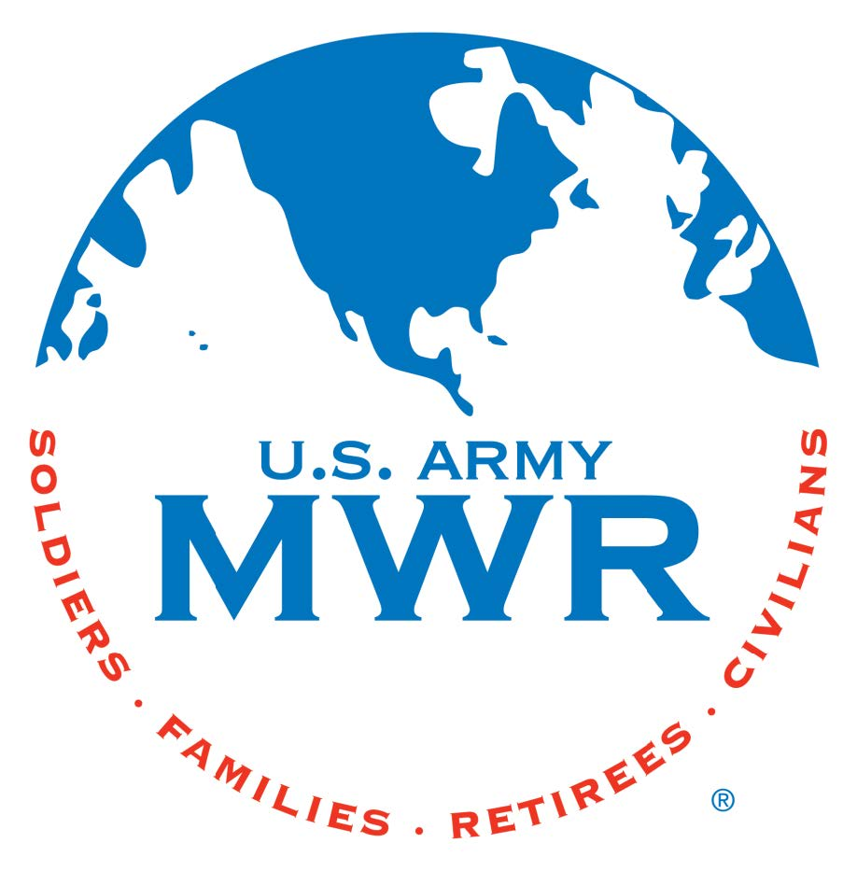
Family and Morale, Welfare and Recreation
JBM-HH Marketing
102 Custer Road, Building 203
Fort Myer, Va 22211
Phone: 703.696.8865

